3rd GRADE ELA SUPPLIES
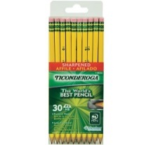
(Take to open house in a bag labeled Mr. Anglin or Ms. Toney and your first and last name)
• Two pks. of sharpened #2 pencils
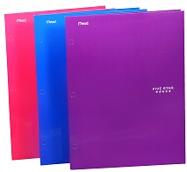
(Ticonderoga brand is the most durable.)
• Two durable folders with your name -
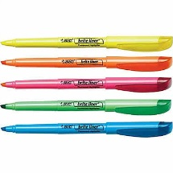
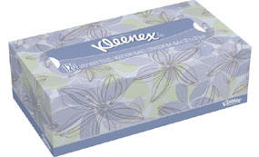
writing with black marker on the front
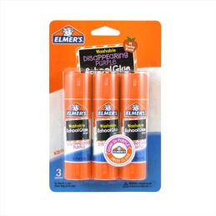
• One box of tissues
• Two thin highlighters
• Three Elmer’s glue sticks (0.77 oz. each)
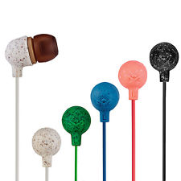
• 1 pair of headphones or ear buds in a Ziploc bag marked with your first and last
name

3rd GRADE MATH SUPPLIES
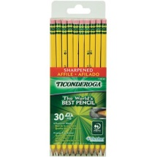
(Take to open house in a bag labeled Mrs. Benedict or Miss Phillian and your first and last name)
• Two pks. of sharpened #2 pencils
(Ticonderoga brand is the most durable.)
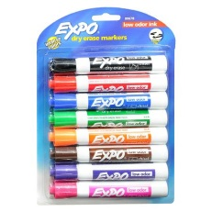
• One box of tissues
• Two thin highlighters
• One 8 pkg. low odor dry erase markers
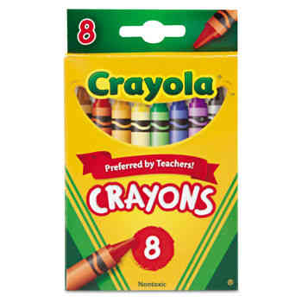
• Three Elmer’s glue sticks (0.77 oz. each)
• One 8 pack Crayola Crayons

PLEASE DO NOT SEND A PENCIL BOX TO SCHOOL FOR EITHER SUBJECT.

